TEAMS 5.1.1|Release Date 7.15.2020

ABILITY TO ADD NON NRS APPROVED ASSESSMENTS

Purpose
The COVID-19 pandemic effected local programs capability to perform in person NRS approved testing for participants and this has hindered the ability for grantees to enter students into the statewide data reporting system, TEAMS. Enhancements to the system has enabled users the ability to track non NRS tested students in the system to maintain current data entry processes and expectations regarding collection of participant information.

Participant Assessment Page
The participant Assessment page is located at the below path:
Home> Participant Search> Participant Record> Assessment

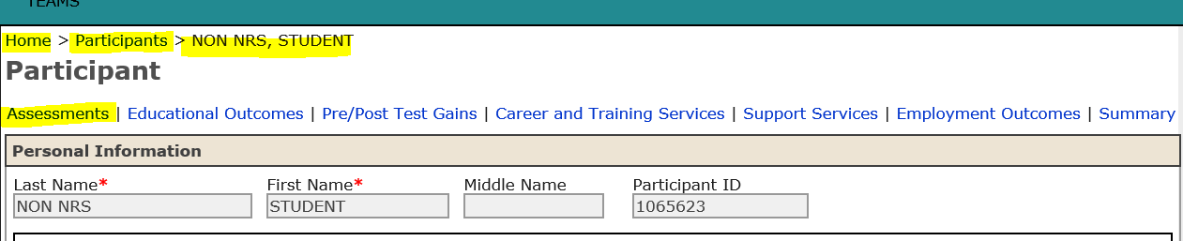

Non NRS Designated Students
You will now have the ability to add a ‘Non-NRS Approved Assessment’ to a student who is unable to take either a remote or in-person proctored NRS approved test, such as TABE 11&12, CASAS, or Best Plus 2.0 due to the limitations of access related to pandemic safety.

You will select ‘Add Assessment’.

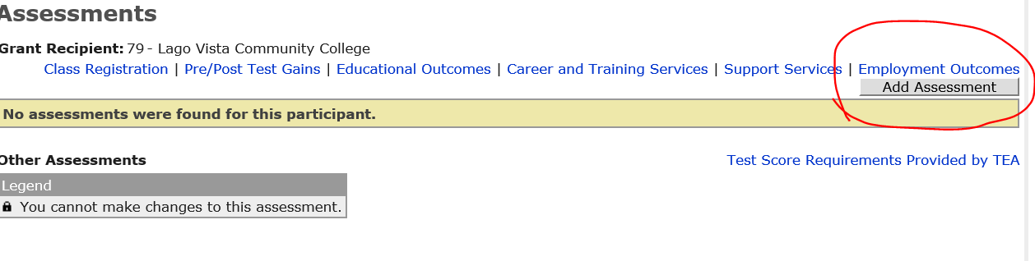

You will select one of these Non NRS approved options in the drop down:
Non-NRS Approved Assessment—any informal staff determined eligibility per TWC guidance listed in ‘Serving Students at a Distance’ document at https://tcall.tamu.edu/docs/ServingNewStudentsAtADistance.pdf or those that fall under Non NRS approved test definition listed in AEL Letter 03-20 which states “test that is not approved for performance accountability under the NRS, such as, but not limited to, the Test of Adult Basic Education (TABE) Placement Locator, TSIA, GED Ready®, HiSET® Interactive Practice Tests, and tests included in commercial learning software programs.

You will notice that some of the test mentioned as options for Non-NRS approved test in AEL Letter 03-20 are separate options in TEAMS assessment drop down. You may choose to select ‘Non-NRS Approved Assessment’ or these other options specifically, in the drop down:
TABE® Locator
Hi Set® Official Practice Test
GED® Official Practice Test
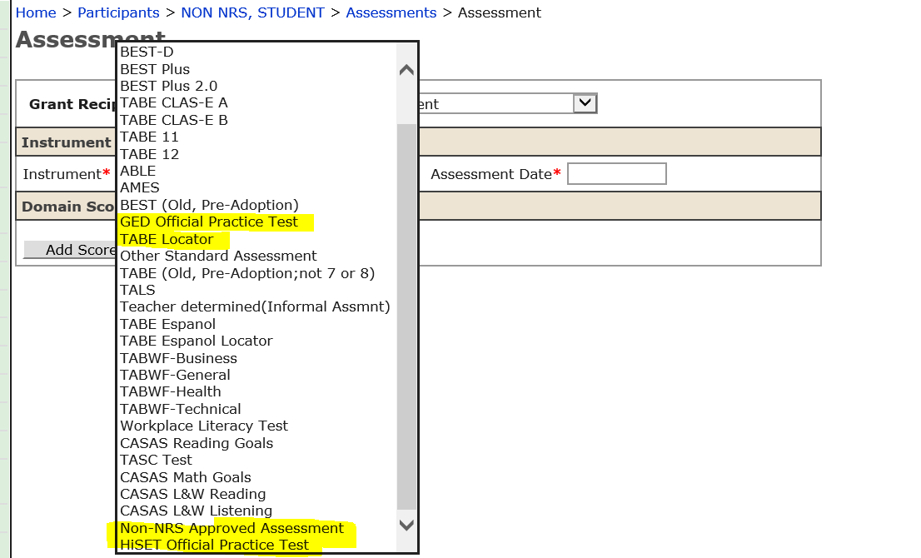

Once you have selected the Non-NRS approved instrument, you will need to determine a provisional functioning level to unofficially place the student for instructional purposes. These levels are provisional based on the information obtained from the student during the intake process and are ultimately determined by the grantee. Only students tested with the Approved NRS test as indicated in our AEL Assessment Guide will count toward performance indicators.
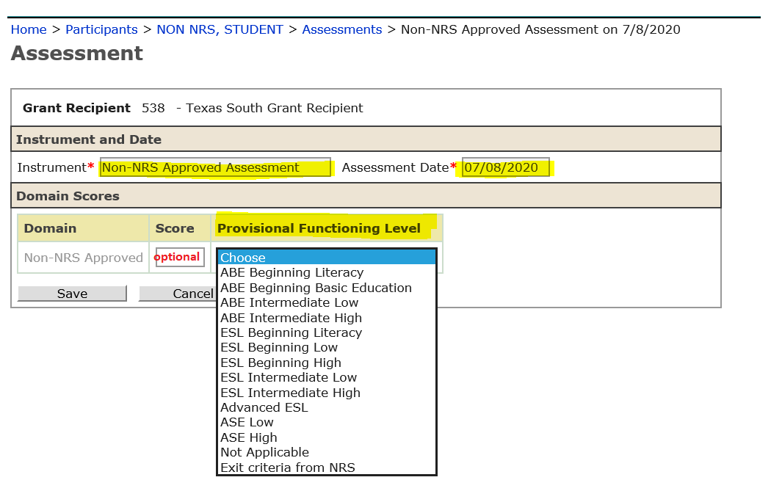

Once you have entered this information, click ‘Save’ and the test will show under the ‘Other Assessments’ section on the participant’s Assessment Page.
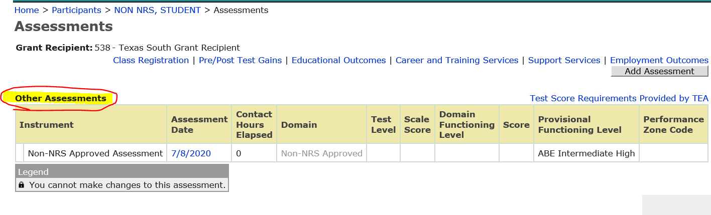

Now, you can enter the students into a Non-NRS class.

ABILITY TO DESIGNATE NON NRS CLASSES

Non NRS Designated Classes
We had to create a placeholder class in TEAMS for new students who do not have a valid test in TEAMS within the last 365 days prior to class registration and first contact hour. Only Non-NRS designated students can be assigned to these classes.

Creating a Non NRS Class
You will create a Non NRS class the same way you would a regular class with the exception of a designation field that indicates that all students registered in this TEAMS class do not yet have a NRS approved test.

These classes will operate in parallel to its counterpart that contains the NRS tested students.

Example: In real life, Mrs. Jane teaches an ESL class with 40 participants. Twenty of those students have a valid NRS approved test and twenty do not. In TEAMS, Mrs. Jane would be attached to two parallel classes to track the instructional activities; one class for those with a valid NRS test and one class for those who do not.

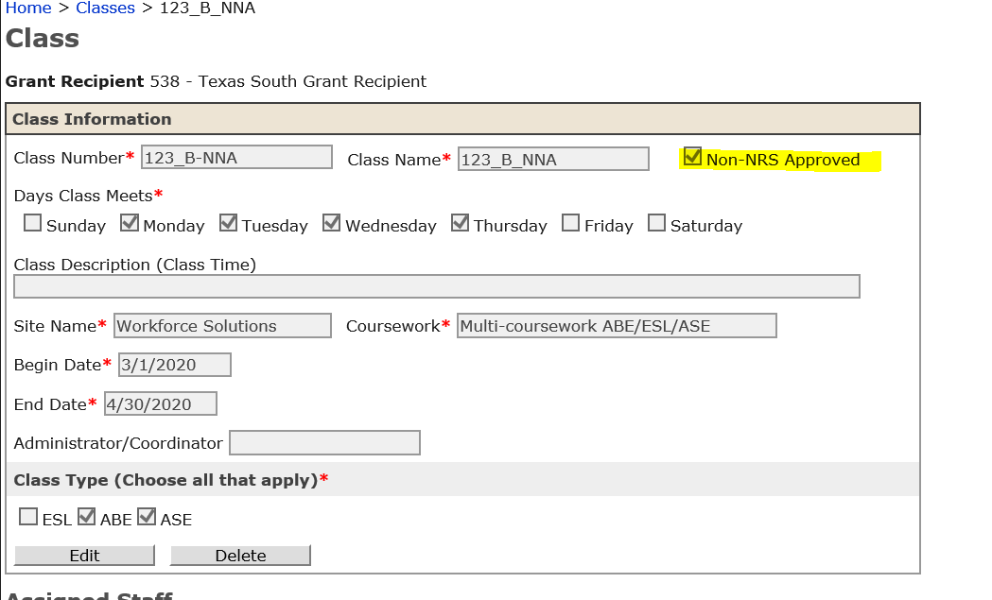

Only Non NRS designated students can be registered to a Non NRS class. Once the student has an ‘Approved NRS test’, that student must be registered for the parallel regular class and all contact hours tracked there.

Important Note: Only students with NRS Approved test will be counted for performance purposes. All contact hours accrued prior to an official NRS approved test will not count toward performance.

Parallel Classes
By having parallel classes and a cohesive naming convention, you will be able to manage the active students more easily.

In this example, you see one physical/virtual class, but two TEAMS classes with clear designation of how many active students do not have an NRS approved test.
All contact hours can be tracked per usual for Non NRS designated classes.
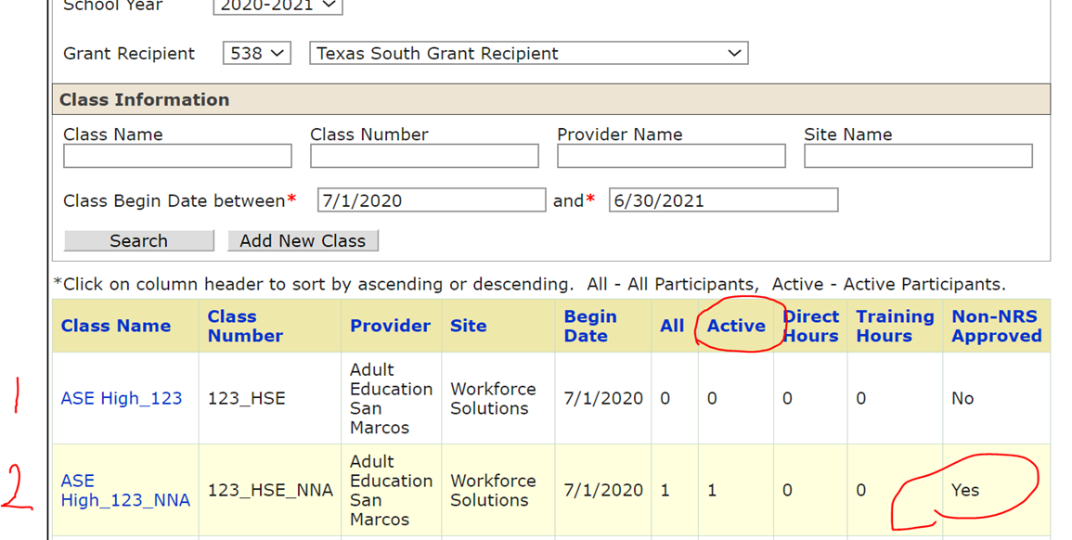

You will still be able to enter direct, proxy and training hour option in a Non NRS designated class and review those classes on the ‘Classes’ section from the TEAMS Home Page. All the information on this page is tabulated the same as any other regular class including, all students, active students, total direct and training hours per class.

All classes that were designated during development as Non NRS, will show in the new ‘Non-NRS Approved’ column.

KEY BUSINESS RULES
- Once a student receives a NRS-Approved test, you will no longer be able to enter contact hours under the Non NRS class, you will receive an error instructing you to move the student to another class.
- Those with ‘write-level’ access will be able to perform these data entry functions same as with regular participants and class development.

